**Praktikum 3 Sistem Basis Data 2023**

**NRP / Nama :** 5025221191/Ahmad Fatih Ramadhani **Kelas :** G

**RDBMS :** MySQL

**Link SQL :** <https://docs.google.com/document/d/18mCLCLox7V0ya-jJJNww4jF3J4uHn_chuKlXyQSG-j8/edit?usp=sharing>

**Kode Asdos :** SBDG01

**Sesi : Modul Pendahuluan**

**Nomor 1**

Sintaks:

**SELECT** *

**FROM** transaksi

**WHERE** tanggal_transaksi **BETWEEN** '2023-10-10' **AND** '2023-10-20';

Hasil:

**Nomor 2**

Sintaks:

**SELECT** t.id_transaksi,**SUM**(m.harga_minuman * tm.jumlah_minuman) **AS** TOTAL_HARGA

**FROM** transaksi t

**JOIN** transaksi_minuman tm **ON** t.id_transaksi = tm.tm_transaksi_id

**JOIN** menu_minuman m **ON** tm.tm_menu_minuman_id = m.id_minuman

**GROUP** **BY**

t.id_transaksi;

Hasil:

**Nomor 3**

Sintaks:

**SELECT**

c.*,**COALESCE**(**SUM**(mm.harga_minuman * tm.jumlah_minuman), 0) **AS** Total_Belanja

**FROM**

customer c

**LEFT** **JOIN** membership mship

**ON** c.id_customer = mship.m_id_customer

**LEFT** **JOIN** membership m

**ON** mship.id_membership = m.id_membership

**LEFT** **JOIN** transaksi t

**ON** c.id_customer = t.customer_id_customer

**LEFT** **JOIN** transaksi_minuman tm

**ON** t.id_transaksi = tm.tm_transaksi_id

**LEFT** **JOIN** menu_minuman mm

**ON** tm.tm_menu_minuman_id = mm.id_minuman

**WHERE** t.tanggal_transaksi **BETWEEN** '2023-10-03' **AND** '2023-10-22'

**GROUP** **BY**

c.id_customer

**ORDER** **BY**

c.nama_customer **ASC**;

Hasil:

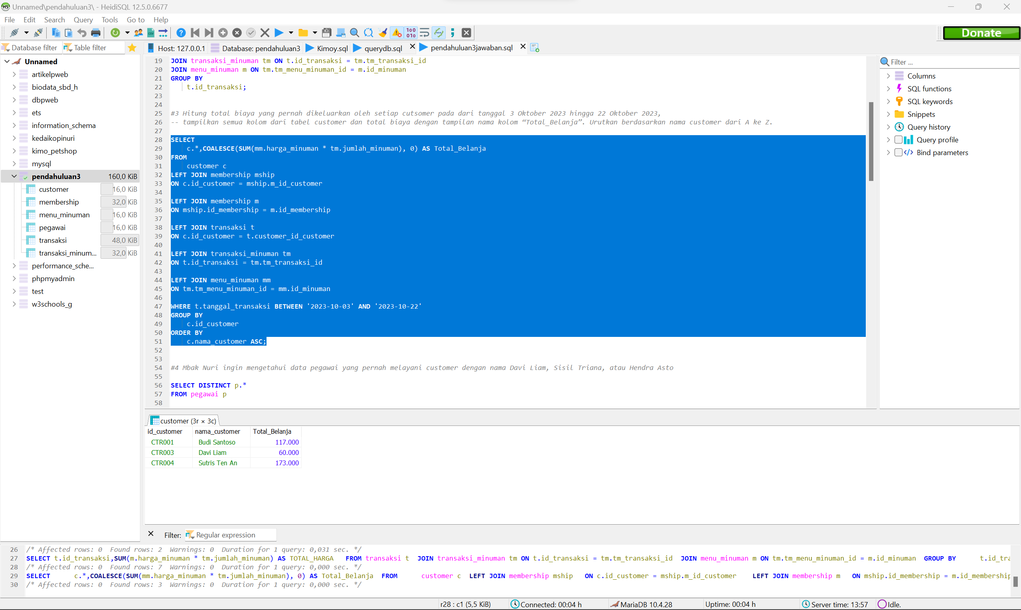

**Nomor 4**

Sintaks:

**SELECT** **DISTINCT** p.*

**FROM** pegawai p

**JOIN** transaksi t

**ON** p.nik = t.pegawai_nik

**JOIN** customer c

**ON** t.customer_id_customer = c.id_customer

**WHERE**

c.id_customer **IN** ('CTR003', 'CTR002', 'CTR005');

Hasil:

**Nomor 5**

Sintaks:

**SELECT** **MONTH**(t.tanggal_transaksi) **AS** BULAN, **YEAR**(t.tanggal_transaksi) **AS** TAHUN,

**SUM**(tm.jumlah_minuman) **AS** JUMLAH_CUP

**FROM** transaksi t

**JOIN** transaksi_minuman tm

**ON** t.id_transaksi = tm.tm_transaksi_id

**JOIN** menu_minuman mm

**ON** tm.tm_menu_minuman_id = mm.id_minuman

**GROUP** **BY**

BULAN, TAHUN

**ORDER** **BY**

TAHUN **DESC**, BULAN **ASC**;

Hasil:

**Nomor 6**

Sintaks:

**SELECT** **AVG**(Total_Belanja) **AS** rata2_total_belanja

**FROM** (**SELECT** **SUM**(mm.harga_minuman * tm.jumlah_minuman) **AS** Total_Belanja

**FROM** transaksi_minuman tm

**JOIN** menu_minuman mm **ON** mm.id_minuman = tm.tm_menu_minuman_id

**GROUP** **BY** tm.tm_transaksi_id

) **AS** TabelRataRataTotalBelanja;

Hasil:

**Nomor 7**

Sintaks:

**SELECT** c.id_customer, c.nama_customer, **SUM**(Belanja_Customer) **as** Total_Belanja

**FROM** (**SELECT** t.customer_id_customer, **SUM**(mm.harga_minuman * tm.jumlah_minuman) **AS** Belanja_Customer

**FROM** transaksi t

**JOIN** transaksi_minuman tm **ON** tm.tm_transaksi_id = t.id_transaksi

**JOIN** menu_minuman mm **ON** mm.id_minuman = tm.tm_menu_minuman_id

**GROUP** **BY** t.id_transaksi) **AS** RataRataTotalBelanjaPerTransaksi

**JOIN** customer c **ON** c.id_customer = RataRataTotalBelanjaPerTransaksi.customer_id_customer

**GROUP** **BY** c.id_customer

**HAVING** **AVG**(Belanja_Customer) > (

**SELECT** **AVG**(avg_total_belanja)

**FROM** (**SELECT** **SUM**(mm.harga_minuman * tm.jumlah_minuman) **AS** avg_total_belanja

**FROM** transaksi_minuman tm

**JOIN** menu_minuman mm **ON** (mm.id_minuman = tm.tm_menu_minuman_id)

**GROUP** **BY** (tm.tm_transaksi_id)) **AS** RataRataKeseluruhan);

Hasil:

**Nomor 8**

Sintaks:

**SELECT** *

**FROM** customer

**WHERE** id_customer **NOT** **IN** (**SELECT** m_id_customer **FROM** membership **WHERE** m_id_customer **IS** **NOT** **NULL**);

Hasil:

**Nomor 9**

Sintaks:

**SELECT** **COUNT**(**DISTINCT** c.id_customer) **AS** jumlah_customer_latte

**FROM** customer c

**JOIN** transaksi t **ON** c.id_customer = t.customer_id_customer

**JOIN** transaksi_minuman tm **ON** t.id_transaksi = tm.tm_transaksi_id

**JOIN** menu_minuman mm **ON** tm.tm_menu_minuman_id = mm.id_minuman

**WHERE** mm.id_minuman = 'MNM003';

Hasil:

**Nomor 10**

Sintaks:

**SELECT** c.nama_customer, mm.nama_minuman, **SUM**(tm.jumlah_minuman) **AS** total_jumlah_cup

**FROM** customer c

**JOIN** transaksi t **ON** c.id_customer = t.customer_id_customer

**JOIN** transaksi_minuman tm **ON** t.id_transaksi = tm.tm_transaksi_id

**JOIN** menu_minuman mm **ON** tm.tm_menu_minuman_id = mm.id_minuman

**WHERE**

c.nama_customer **LIKE** 'S%'

**GROUP** **BY**

c.nama_customer, mm.nama_minuman;

Hasil:

